

TOPAS 2581B
Performance Specification for Pedestrian Countdown units for use at Traffic Signals

Revision | Date | Scope | Authorised by
A (v1) | 06/01/15 | Draft | Admin
A (v2) | 19/03/15 | Review | MAC
A (v3) | 20/03/15 | Draft | Admin
A (V4)  A (v5)  B | 27/03/15  11/03/16  27/11/25 | Final  Final  Draft | Board  Board  TBC

© Traffic Open Products And Specifications Limited 2025.

This document is the property of Traffic Open Products And Specifications Limited and shall not be reproduced in any media in part or in full without the prior written permission of Traffic Open Products And Specifications Limited unless this copyright statement is attached.

Contains public sector information licensed under the Open Government Licence v3.0 and are reproduced and adapted by permission.

Limitation of Liability

Traffic Open Products And Specifications Limited does not accept any liability for any losses damages injury or death or other adverse consequence arising from the use or application of this document and the information therein.

(This page intentionally left blank)

TOPAS 2581B
PERFORMANCE SPECIFICATION FOR PEDESTRIAN COUNTDOWN UNITS FOR USE AT TRAFFIC SIGNALS
CONTENTS
Section
1.Introduction
2.Functional Requirements
3.Optical Requirements
4.Electrical Requirements
5.References

Appendix A Informative Guide
Appendix B Dimensions & Mounting Arrangements
Appendix C Fault Monitoring
Appendix Z Technical File Content

CHANGE LOG

Changes that do not affect existing registrations

Changes to section 1.
Re-ordering of entries in section 4 to separate power and interface definitions

Changes that may affect existing registrations

3.3 The on-axis bright luminance has been defined as a minimum value.

3.4 Luminance in dim has been set at 15% - 38% of bright to align with other traffic signals products

3.7 A measurement method and quantification of phantom have been added.

2.28 Labelling and Marking Requirements moved to core requirements.

Introduction
Scope
  - This specification covers the requirements for pedestrian countdown units for use at traffic signals.
Approval
  - TOPAS specifications are explicitly purchasing specifications and compliance with them is not mandatory. However Local and other Purchasing Authorities may typically require that equipment purchased complies with TOPAS specifications and is TOPAS registered.
  - Manufacturers may register products as being compliant with this specification, using the process defined in TOPAS 0600
  - TOPAS registration requires manufacturers submit a Technical File to an appropriate Technical Assessor to aid compliance verification. The content requirement for the Technical File is defined in Appendix Z of this specification.
  - Guidance to potential users of this Product is given in Appendix A
Implementation
  - This specification will be immediately implemented from the date of issue for all new TOPAS Registrations.
Glossary of Terms
  - A comprehensive glossary of terms and abbreviations may be found in the Institute of Highway Engineers guidance note “Traffic Control and Information systems”.
  - TOPAS Terms are defined in TOPAS 0600.

Functional Requirement

  - The Product shall be capable of displaying a numerical indicator to count down the pedestrian blackout period.
  - The pedestrian blackout period is defined as the period during which neither the red pedestrian signal nor the green pedestrian signal are illuminated.
  - The Product shall be a self-contained unit, and must only be used at traffic signals to regulation 33 of TSRGD in conjunction with pedestrian light signals to diagram 4002.1 or toucan light signals to diagram 4003.5 of TSRGD.
  - See APPENDIX B Dimensions and Mounting Arrangements in relation to diagram 4002.1
Operation and Timing
  - a) The Countdown Duration shall be a stored value equal to the pedestrian blackout period.
b) The blackout period of the pedestrian signals with which the countdown timer is associated shall be determined by monitoring of the signalling sequence of these associated red and green pedestrian signals. Such monitoring shall operate correctly when the associated pedestrian signals are running in either the bright or the dimmed state.
Start up Sequence
  - On switch-on or restoration of power supply the Product shall display a blank (unlit) face until the Countdown Duration is set.
Timing
  - A means shall be provided by which the Product synchronises display with the blackout period.
  - A means shall be provided to ensure reliable and accurate monitoring of the blackout.
  - All time periods shall be accurate to within 40ms.
Display
  - The display shall activate at the expiry of the green pedestrian signal at which point it displays the value of the countdown period.
  - The Product shall count down in whole seconds the Countdown Duration
  - The Product shall extinguish the display at the start of the red pedestrian signal.
  - In the event that the Product detects that the blackout period has changed, the Product shall extinguish the display until it has incorporated the change of blackout period into its operation, and the countdown duration matches the blackout period again.
Power Supply Interruptions
  - In the event of a power supply interruption to the Product equal to or less than the relevant value in Table 1 the Product shall continue to function correctly.
  - In the event of a longer power interruption that affects the operation of the Product the Product shall shutdown in a safe manner. On restoration of power the Product shall follow the sequence specified in 2.6.
  - The Product shall meet one of the classes in Table 1 - Power hold-up times as determined by the purchasing Traffic Authority.
Class | Minimum hold up time
- B1 | - 50ms
- B2 | - 100ms
- B3 | - 200ms
- B4 | - 300ms
Table 1 - Power hold-up times
Fault Modes And Responses
  - The Product shall monitor its own operation and shutdown in a safe manner within 100ms if it detects a critical fault condition.
  - Shutting down in a safe manner means extinguishing the display and where fitted, signalling a fault state on the fault output of the type defined in Appendix C.
  - A critical fault condition is defined as a fault which may either cause the display to activate at a time other than the pedestrian blackout or lead to a display that might be misinterpreted.
Reliability
  - The product shall be designed for a service life of 10 years.
Construction and Dimensions
  - The Product and its housing shall meet the requirements of BS EN 50556 to the classes defined in TOPAS 2130.
  - The Product must meet the dimensions and the placement of the Product relative to the associated pedestrian signals as shown in Appendix B (copied from TSRGD).
Additional Requirements
  - Individual Products may be designed to perform to Appendix C.
  - A facility to monitor the associated red and green pedestrian aspects may be provided within the Product.
  - If provided, the Product shall monitor these aspects and should either or both aspects fail, the Product shall extinguish its display until such a time as the aspect is functional.
  - Upon restoration of both red and green pedestrian aspects, the Product shall follow the start-up sequence set out in paragraph 2.6.
Labelling and Marking
  - Each Product shall be fitted with a label displaying the following:
- The unique Product identifier and serial number;
- The TOPAS Specification against which it has been declared compliant;
- The electrical supply requirements and power consumption of the equipment when displaying 08.

Optical Requirements

  - Appendix B “Dimensions and Mounting Arrangements” shows the overall maximum dimensions for the light emitting areas of the numerical digits and the minimum dimensions in brackets. The dimensions chosen shall correspond with one another so that the shape and proportions of the sign are, so far as reasonably practicable, consistent.
Chromaticity
  - All parts of the numerical display of the Product shall meet the chromaticity requirements of one of
- C2 yellow,
- white
as defined in BS EN 12966-1:2005+A1:2009 - Road Vertical Signs - Variable Message Signs Part 1.
Luminance
  - In “Bright” mode the minimum on-axis luminance intensity of the numerical display shall be 200cd, when displaying “08”.
  - In “Dim” mode the on-axis luminance intensity of the numerical display shall be between 15% and 38% of “Bright” mode luminance when displaying “08”.
Viewing Angle
  - When measured at 40 degrees, left of, right of, and below the optical axis the luminous intensity shall be greater than 30% of the measured on axis luminous intensity.
  - Viewing angle restriction may be provided using some form of visor or masking system.
  - The Product should, by design, minimise the effects of phantom illumination, such that there is no discernible display due to phantom illumination at any time. When measured using the test method of BS EN 12368 the ratio of on-axis luminous output to phantom shall be no less than 16:1.
Dimming Control
  - The Product display shall be capable of being dimmed and dimming performed by the Product determining the intended bright or dim state by monitoring the voltage on the incoming red / green pedestrian signal lines. The Product shall use the voltages as defined in TOPAS 2523 to determine the appropriate dimming state.

Electrical Requirements

Power

  - The Product shall be powered by a separate cable and not draw power from the associated red or green pedestrian signals.
  - The purchasing Traffic Authority shall specify one of the recommended operating voltages shown in Table 2 and defined in TOPAS 2523.
Class | Nominal Supply Voltage  (Tolerance)
C1 | 24V AC (+/- 20%)
C2 | 24V DC (+/- 20% )
C3 | 48V DC (-8V +1V)
C4 | 230V AC (-13% +10%)
Table 2 - Supply Voltages

  - The typical working power consumption should be as low as possible.
Interfaces
  - The Product shall interface with the existing red and green pedestrian signal lines.
  - All monitoring inputs to the Product shall be electrically isolated.
  - The Product shall interface with both Extra Low Voltage (ELV) or Low Voltage (LV) Red and Green Pedestrian Signal inputs as defined in BS EN 50556.
  - ELV voltages described in 4.6 shall not exceed the limits defined in BS 7671.
  - The load presented to the red and green pedestrian signals shall be as low as possible to avoid affecting the lamp monitoring facilities of the traffic controller whilst avoiding sensitivity to voltages induced on the on-street cabling.

References
  - Where undated references are listed, the latest issue of the publication applies.
British Standards
  - British Standards are published by the British Standards Institution, London.
BS 7671 | Requirements for Electrical Installations
BS EN 50556 | Road Traffic Signal Systems
BS EN 50293 | Electromagnetic Compatibility Road Traffic Signal Systems Product Standard
BS EN 60529 | Specification for Degrees of Protection Provided by Enclosures (IP Code)
BS EN 12966-1: 2005+A1:2009 | Road vertical signs – Variable message traffic signs – Part 1: Product standard
BS EN 12368 | Traffic Control Equipment - Signal Heads
Specifications
  - Topas Limited.Specifications are available from www.topasgroup.org.uk
TOPAS 2130 | Environmental Tests for Road Traffic Control Equipment
TOPAS 2500 | Specification for Traffic Signal Controllers
TOPAS 0600 | TOPAS Registration Process
TOPAS 2523 | Traffic Control Equipment Interfacing Specification
TA 84 | Design Manual for Roads and Bridges Volume 8 Section 1 Part 2: Code of Practice for Traffic Control and Information Systems for All-Purpose Roads.
Legislation
The Traffic Signs Regulations and General Directions 2016 (SI 20162/362) (as amended)

Directive 2004/108/EC
Electromagnetic Compatibility Regulations 2006 (SI 2006/3418)

Directive 2006/95/EC
The Electrical Equipment (Safety) Regulations 1994 (SI 1994/3260)

APPENDIX A - INFORMATIVE GUIDE
General
  - This Appendix is an informative guide to Traffic Authorities and their contractors who wish to purchase and\or use Pedestrian Countdown Equipment that has been declared conformant to this specification.
  - (Clause deleted)
  - Purchasers shall ensure that the countdown unit is compatible with the signalling equipment to which it is to be mounted and connected.
Compatibility
  - The procurement contract should specify the mounting method required.
Marking and Labelling
- Moved to body requirements
Connection Lead
  - Where the Product is supplied with a single connection plug and fly-lead (allowing for ease of replacement) the procurement contract should specify that the plug be a 7 pin IP68 rated plug.
  - Where supplied the fly lead should be at least 2.5m long, using multi-stranded cores and with individual cores coloured as defined in Table 3.
  - Faults which may be considered as critical could include the following:
- Single Segment permanently on
- Loss of two or more segments
- Internal watchdog failure
- Loss of timing functions

Function | Wire Colour | Connector Pin
Power supply +ve | Red | 1
Neutral line | Blue | 2
Green Pedestrian Signal | Green | 3
Monitoring line Return  (Optional) | Yellow | 4
Monitoring Line  (Optional) | White | 5
Power supply -ve | Black | 6
Red Pedestrian Signal | Brown | 7
Table 3 - Fly-lead Connections

APPENDIX B - Dimensions and mounting arrangements

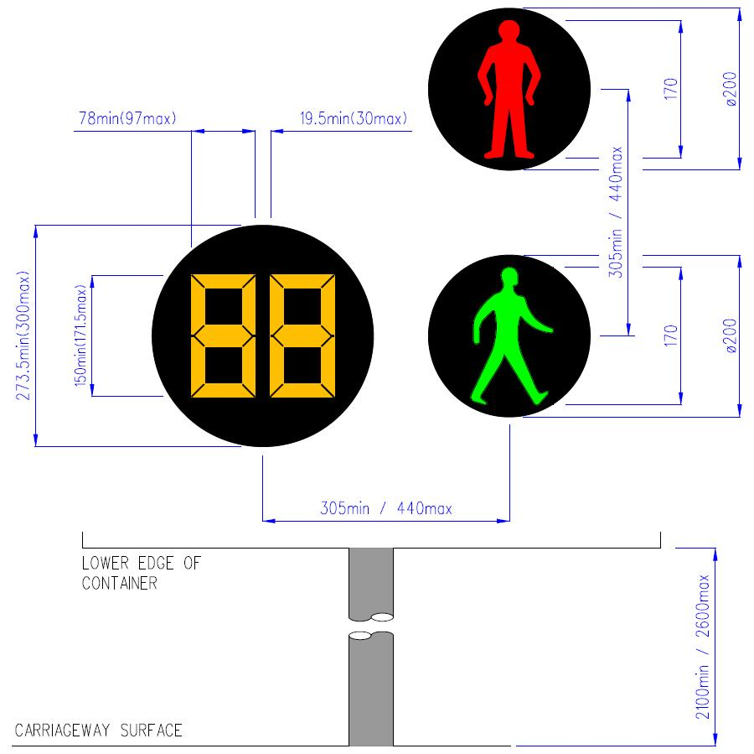
Left Hand side mounting

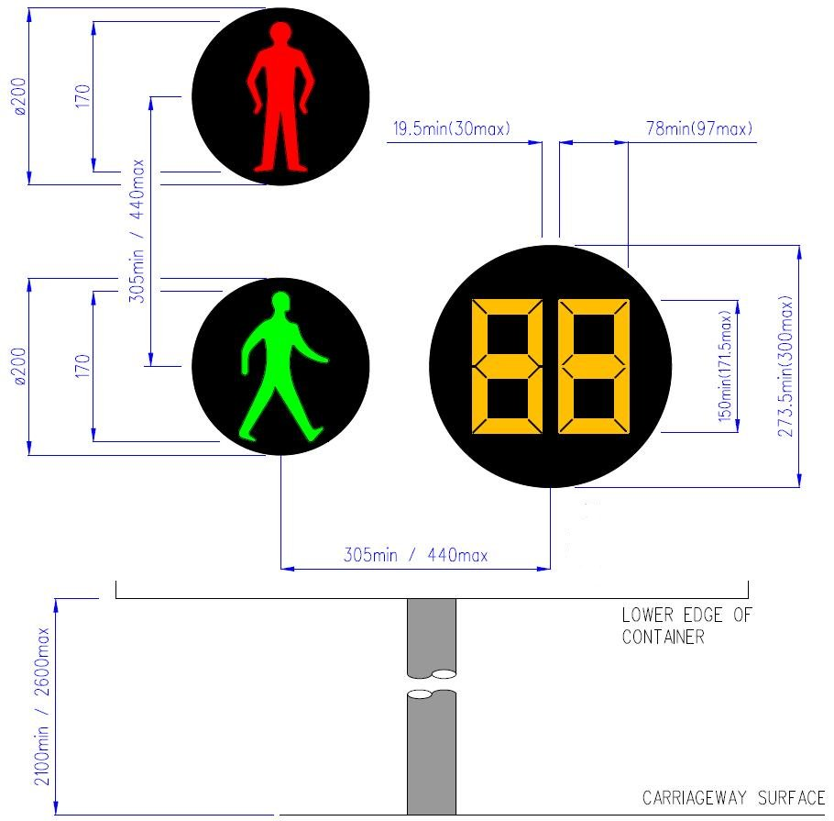

Right Hand side mounting

APPENDIX C - Fault monitoring

  - The Product may provide the following facilities for fault monitoring.
General
  - Where required the Product shall provide a monitoring line output, which is connected to the controller to signal a fault condition has occurred.
  - This monitoring line shall be a normally open volt free switch. Under a normal fault-free operation the Product shall force the volt free switch closed.
  - Under any fault condition the Product shall release (open) the volt free switch, signalling a fault to the Traffic Signal Controller. i.e. if the presence of a fault on the Product or a loss of power to the Product the monitoring line shall take the fault state.
  - In addition to opening the volt free switch the unit shall provide a visual indication of the fault state.
  - The Product may be monitored by the Traffic Signal Controller via the monitoring line.
  - All faults (critical and non-critical) shall be reported by the Product using the monitoring feedback line, although no distinction needs to be made between the two.
Failure modes
  - In addition to the Critical Faults detailed in Section 2.19 the Product may also report non-critical faults.
  - Non-critical faults are defined as those faults which do not cause the display to activate at a time other than the blackout or lead to a display that might be misinterpreted.
  - These faults shall require reporting via the monitoring line but do not affect the continuous safe operation of the Product.
  - If at any point the non-critical fault ceases to be present the Product should close the volt free switch to clear the reported fault unless another fault is present.
  - The Unit shall attempt to auto-recover from any non-critical fault after 60s. If the fault is still present it shall continue to attempt an auto-recover up to 10 times within a 24 hour period after which it should remain in a fault state.
Monitoring Line Interface
  - The monitoring line shall be connected to the Traffic Signal Controller inputs. The Product(s) shall present itself in the same manner as detecting equipment whose interface requirements are set out in TOPAS 2523.
  - Under normal conditions the Product will present a ‘Logic 0’ state as defined in TOPAS 2523 (Short Circuit).
  - Under fault conditions the Product will present a ‘Logic 1’ state as defined in TOPAS 2523 (High Impedance).
  - The option to connect multiple Products serially to a single controller input whilst meeting the requirements of paragraph C.13 is permissible.
On Board Diagnostics
  - During a fault condition the Product shall provide an externally visible indication of which fault has occurred.
  - The Product shall include an non-volatile historical log of all faults capable of storing a minimum of 255 entries. Each log entry shall have a unique fault identification.

- technical file content

This appendix defines the necessary content for a Technical File (a collection of relevant documents) which shall be reviewed by an appropriate Technical Assessor as part of the TOPAS Registration process (See TOPAS 0600).

The ‘ticked’ items are required to be present in a Technical File used to support TOPAS Registration against TOPAS 2581A. Please read the description criteria carefully.

Ref | Item | Description | Required
1 | Overview document | A summary document outlining the product, specifying which TOPAS and other relevant specification(s) the product has been designed to comply with, together with a detailed table of contents for the Technical File.  Where external certificates or documents are referred to these shall be included either:  (a) within this overview document; or  (b) supplied separately as part of this Technical File. | √
2 | QA accreditation certificate(s) | A copy of the Quality Management Registration Certificates for the organisation applying for TOPAS Product Registration. | √
3 | Details of all required standards and regulations including CE/CA requirements that apply to the Product | A list of all standards to be complied with.  Including explicit CE/CA declarations of performance/conformity for those standards, including all certificates, shall be included in this Technical File. | √
4 | A functional design description of the product | Title, document number, version and date of the overall System Design Document for the Product. | √
5 | Product part numbers | A list of top-level assembly part numbers and their issue states including all firmware / software part numbers and issues. | √
6 | Statement of Compliance | A clause-by-clause statement of compliance against TOPAS 2581A confirming compliance or non-compliance and referencing supporting evidence.  (An example template can be found on the TOPAS website) | √
7 | Functional test procedures and results | A list of all functional test schedules and test result documents (by document number and issue) that substantiate the Statement of Compliance. | √
8 | BS EN 50293 EMC test procedures and results | - Title, document number, version and date of the EMC test performance requirement document.  - Copies of the results of EMC testing undertaken by an appropriately qualified independent approved test house shall be included in the Technical File. | √
9 | Optical test procedures and results required by this specification | For all products which have any defined optical performance requirements  - Title, document number, version and date of the optical test performance requirement document.  - Copies of the results of optical testing undertaken by an appropriately qualified independent approved test house must be included in the Technical File. | √
10 | Environmental test results | - A list of relevant Environmental tests performance requirements defined in TOPAS 2130.  - Copies of the results of the Environmental testing undertaken by an appropriately qualified independent approved test house must be included in the Technical File. | √
11 | Radio Equipment Regulations test results | For all products which include any transmitting and/or receiving radio equipment  - A copy of the RER Declaration Of Conformity  - Reference to the RER Technical Documentation for the product (by title, document number and version).  - Copies of the results of radio testing, undertaken by an appropriately qualified independent approved test house must be included in the Technical File. The test results should be those identified in the RER Technical Documentation and should cover any specific IR2030 requirements for the type of radio used.  - A copy of the Type Examination Certificate for radio equipment not covered by a Designated EN standard. | N/A
12 | Primary Safety Test procedure and results | For Traffic signal Control equipment only:  - The title, document number, version and date of the Primary Safety Test schedule.  - A copy of the test results must be included as part of the Technical File. | N/A
13 | Failure Mode Analysis | For Traffic signal Control equipment only  Title, document number, version and date of the product failure mode analysis requirements and results. | N/A

