

TOPAS 2515D
Performance Specification for Equipment to Detect High and Over-height Vehicles at Low Structures

Revision | Date | Scope | Authorised by
D(V2) | 09/12/25 | Draft | Dave Cousins

© Traffic Open Products And Specifications Limited 2025.
This document is the property of Traffic Open Products And Specifications Limited and shall not be reproduced in any media in part or in full without the prior written permission of Traffic Open Products And Specifications Limited unless this copyright statement is attached.
Contains public sector information licensed under the Open Government Licence v3.0 and are reproduced and adapted by permission.
Limitation of Liability
Traffic Open Products And Specifications Limited does not accept any liability for any losses damages injury or death or other adverse consequence arising from the use or application of this document and the information therein

(This page left intentionally blank)

TOPAS 2515D
PERFORMANCE SPECIFICATION FOR EQUIPMENT TO DETECT HIGH AND OVER-HEIGHT VEHICLES AT LOW STRUCTURES

CONTENTS

Section
1. Introduction
2. Functional Requirements
3.References
Appendix A Sign Legends for Over Height Vehicle Detection Systems
Appendix B Remote Monitoring Over Height Vehicle Detection Systems
APPENDIX Z technical file content
CHANGE LOG
- 2.27 & 2.28 removed maximum delay requirement
- Additional clarification for 2523 clauses added
- Added fault monitoring section in 2.44
- Adjusted terms to critical and no critical pixel fail or fault throughout spec.
- User interface and fault logs redefined to provide more clarity of mandatory and optional fault monitoring
- 2.34-2.40 made technology agnostic.
- Added clause where remote monitoring required use dedicated OMU interface or use UTMC MIB.
- Updated Appendix B OMU interface so not technology specific and making items mandatory and optional.
- Change watchdog monitoring in 2.21 to optional.
- Change reference to Design authority to manufacturer.
- Adjusted statement for previous approvals against TOPAS2515C
- 2.34 Removed specific environmental requirements covered in TOPAS2130.
- Added bitmap support for Legend type B

Introduction

  - This specification covers the requirements for equipment to detect and protect low structures from overheight vehicles on all public highways.
  - TOPAS specifications are explicitly purchasing specifications and compliance with them is not mandatory. However Local and other Purchasing Authorities may typically require that equipment purchased complies with TOPAS specifications and is TOPAS registered.
  - Manufacturers may register products as being compliant with this specification, using the process defined in TOPAS 0600
  - TOPAS registration requires manufacturers submit a Technical File to an appropriate Technical Assessor to aid compliance verification. The content requirement for the Technical File is defined in Appendix Z of this specification.
  - Guidance to potential users of this Product is given in Appendix A.
  - Within this specification, “The Product” shall mean all components necessary to provide a complete operational unit meeting the requirements of this specification and the common requirements defined in TOPAS 0600.

Implementation
  - This specification will be immediately implemented from the date of issue for all new TOPAS Registrations.
  - For Products previously registered against TOPAS 2515C manufacturers are simply required to confirm in writing that the products remain compliant with this amended specification. Once confirmed the product registration will be migrated on the TOPAS website.
  - This specification will be immediately implemented from the date of issue for all new TOPAS Registrations

Glossary of Terms
  - A comprehensive glossary of terms and abbreviations may be found in the Institute of Highway Engineers guidance note “Traffic Control and Information systems”.
  - TOPAS Terms are defined in TOPAS 0600 and TOPAS 0601.

Functional Requirements
General
2.1 This specification covers the operational requirements of a Product for detecting high and over-height vehicles at restricted height structures.

2.2 The Product defined in this specification may include all or a sub-set of the following:
Controller
Height detector (HD)
Vehicle Presence Detector (VPD)
Structure Incident Detector
Message Signs
2.3 Where a low structure protection scheme includes message signs these signs shall conform to BSEN12966 and the messages displayed on those signs to TSRGD. (Such messages typically convey warnings and route choice information.) Messages are prescribed in TSRDG schedule 16 Part 2.
2.4 A means of height detection, prior to the sign, is used to detect over-height vehicles.
  - Height detection methods shall be designed to provide reasonable immunity to false detections caused by environmental conditions, and other triggers while having a high level of confidence in detecting vehicle height. Particular requirements are given in sections 2.38 to 2.45.
  - If a vehicle is detected as being over-height a trigger shall be sent to the message signs of section 2.3 above to display the appropriate message.

  - Vehicle presence detector/s may be used at the height detector locations as verification of the presence of a vehicle. Particular requirements are given in sections 2.46 to 2.47 below.
  - Where remote monitoring of the system is provided then Structure Incident Detectors may be installed to provide a warning when a possible structure collision/incident has occurred.
  - Where remote monitoring is required, it can support an OMU interface as defined in Appendix B. Alternatively the UTMC MIB Overheight Warning Signs MIB or sections of Remote Monitoring MIB may be used for Remote Monitoring, available from https://topasgroup.org.uk/specifications/.

System Configuration and Operation
  - For all height detection systems signs shall be located on every approach to the structure.
  - On the application or re-application of power to the system it shall become fully operational within 30s.

Single Over-Height Detection
  - For a girder or horizontal bridge decks or structures a single height detection system shall be used.
    - An over-height vehicle is defined as one whose height dimension is too great to pass under the protected structure.
    - If an approaching over-height vehicle is detected and validated, by the presence detector if fitted, then, an output shall be provided to trigger appropriate sign/s to display message B of appendix A and to trigger other equipment.
    - The sign or signs on the opposite side of the structure from the side where the detection occurs shall not be affected.

Dual Over-Height Detection
  - For an arched structure a dual height detection system shall be used.
  - If an over-height vehicle is detected, then the Product shall operate as that defined in paragraphs 2.12.1 through 2.12.3.
    - A high vehicle is defined as one that is too high to pass under the outer parts of an arched structure but may pass under the centre of the arch.
    - If a high vehicle is detected and validated, by the presence detector, then legend C of appendix A shall be displayed for a predetermined time only on the appropriate sign(s).
    - The sign on the opposite side of the structure shall display legend D of appendix A for a predetermined time.
  - When a sign is displaying legend other than a blank face the flashing yellow conspicuity lanterns shall also be operative.
  - When the predetermined display time has expired then the signs will revert to a blank face (message A of appendix A) with the amber lanterns switched off.
  - The Manufacturer shall ensure that where appropriate the provisions of BS EN 60825 Safety of Laser products are incorporated into their design.

Controller
  - The operation of the Product may be based on a single intelligent device or a number of distributed intelligent devices interlinked by a secure communications medium.
  - The Product shall be capable of operating with simultaneous inputs from all detector locations.
  - Clause deleted.
  - The Product shall provide a secure local interface for monitoring of faults.
  - The User Interface should allow system configuration.
  - The user interface should allow the forcing of VMS sign legends.
  - The User Interface should provide a timestamped log of operation of the OVD and fault logging. This should include the monitoring of the following faults:
Mandatory
- Height Detector 1
- Height Detector 2
- Non Critical Pixel failure
- Critical Pixel failure
Optional
- OVD Low Beam Fail
- Presence Detector Fail
- Watchdog Fail
- Sign Controller Fail
- Luminance Failure
- Power Fail
- Amber Lantern Fail
  - The interface to this process may be in any form although it is preferred that an RJ45 socket be provided so that a remote terminal can configure the Product using a web browser session using an IP Address and a secure log-on feature.
  - When an IP address is provided the factory default shall be set as 192.168.1.1. This value shall be configurable by an authorised user.
  - The time between the over-height detection being confirmed and the message being displayed, shall not be greater than 500 milliseconds except where a delay has been defined in the in the site data.
  - The length of time a message can be displayed shall be determined by the site data for each attached VMS. This parameter shall be independently selectable between 1 and 30 seconds in 1-second increments.
  - Controller inputs and outputs shall conform to TOPAS 2523 (Clauses 2.3 and 2.4)
  - The Product shall provide the functionality to operate up to a maximum of eight VMS.
  - Optionally where the VMS can provide an output affirming valid operation then this may be accepted at the controller. The failure of any such signal shall be reported by the controller using the facilities for section 2.21.
  - Where structure incident detectors are provided the controller shall have the capacity to accept inputs from up to 4 such detectors.
  - Where structure incident detectors are provided the controller shall have a configurable facility to delay or extend each structure incident input by up to 30s in 1s steps.
  - Where structure incident detectors are provided the controller shall include a facility to report structure incidents over the remote monitoring interface of section 2.21.
  - The Product shall optionally provide an independent watchdog facility that will monitor the main controller processes and shall cause a category 1 fault condition in the event of a failure.
  - The Product shall provide the necessary algorithms to determine the direction of travel of over-height and high vehicles for all possible operational traffic movements at the measurement location, including for example one over-height vehicle moving away from the protected structure as a second over height vehicle moves towards the same structure.
  - Where timing parameters are included in the algorithms defined in paragraph 2.36 a means shall be included to enable an authorised person to update these on site.

Height Detectors
  - The over-height vehicle detector (OVD) and the high vehicle detector (HVD) shall provide the functionality to detect over-height or high vehicles at a defined height above the road surface for oncoming vehicles only.
  - The height detection means shall operate over a distance of at least 25m across the road surface.
  - The height detectors shall operate in night and daylight conditions. Height detector will be functionally tested during TOPAS2130 environmental tests when the unit is powered and during EN50293 EMC testing. Ensuring no missing or false positive detection.
  - Optical detectors shall conform to the safety requirements defined in BS EN 60825.
  - Clause deleted.
  - The OVD detectors operating at either height 1 or height 1 and 2, alone or in combination with another detector shall ensure only vehicles approaching the height restriction are detected. see Figure 1.2
  - Overheight detectors shall be monitored to ensure correct operation. If the height detector uses a pair of sensors to operate then one can be checked against the other to confirm operation. If a single sensor is used then it must provide a self test facility to confirm it is able to detect. Failure of any Overheight detectors shall cause a category 1-fault.
  - Each height detector shall include a feature that will inform the controller the operational status of each device at intervals of not greater than 300 seconds from the last actuation.

Vehicle Presence Detector VPD
  - The Product may provide equipment that will confirm the presence of a vehicle at the same location as the Over height detectors which will:
- Where provided the presence detector shall be used to inhibit the reporting of detections from non-vehicular obstructions.
- The presence detector shall operate the conditions specified in section 2.40 for height detectors.
- The presence detector shall perform as defined by this specification with a confidence limit of not less than 90%.
  - The presence detector shall include a feature that will inform the controller the operational status of the device at intervals not less than 300 seconds.

Variable Message Signs
  - The VMS deployed, as part of this Product, shall be of the light emitting variety in accordance with BS EN 12966 (UK National Annex), TSRGD 2016 as required by TOPAS 2516 and TOPAS 2515.

VMS Fault Monitoring
  - The VMS must monitor its display pixels as follows
- 1% or more of pixels of the active display are faulty then a Non Critical Pixel Fault shall be recorded.
- A Critical Pixel Fault failure will be recorded at a percentage of failed pixels specified by the manufacturer but no more than 10% of the active display.

If remote monitoring is available, the non critical and critical pixel failures shall be reported. The critical pixel failure fault shall cause a category 1 fault.
  - The VMS will be controlled and monitored by the controller if the VMS loses communications with the controller for more than 2s then the sign fault will cause a category 1 fault.

Structure Incident Detector (Optional)
  - The option shall consist of a supplementary detection system in close proximity to the structures portal.
  - The Product shall provide the necessary processing to discriminate between a stationary queue of normal height vehicles and a stationary over-height vehicle.
  - Where a structure incident detector is provided it shall provide an output to the controller.

Electrical Requirements
  - All equipment shall be suitable for operation in accordance with this specification when connected to the UK mains supply as defined in BS EN50556.
  - All wiring, termination, earthing and labelling shall be in accordance with BS EN50556.
  - In the event of a internal power supply output failure or interruption longer than 50 milliseconds the controller shall cause a category 3 fault.

Construction
  - Clause deleted.
  - The equipment housing shall be constructed in such a manner and from materials to meet the environmental requirements defined in paragraph 2.60.
  - The Product manufactured to this specification shall be designed to have a minimum in-service life of 15 years with suitable maintenance.

Environmental
  - The equipment shall meet the environmental performance requirements as specified in TOPAS2130.

Failure Modes

Category 1
  - The product shall set all operational signs on the affected approach to display legend type E of Appendix A if available or set the amber yellow conspicuity lanterns flashing with a blank sign face.
  - The approach(s) not affected by the fault shall continue to operate as normal.
  - If remote monitoring is available the failure shall be reported.
  - If faults exist on both approaches then the Product shall cause a category 2-fault.
  - When all faults are cleared for an approach then normal operation shall be resumed for that approach within the normal product start up time.

Category 2
  - Any operational signs shall operate as paragraph 2.61.
  - If remote monitoring is available the failures shall be reported.
  - When all faults are cleared for any approach then normal operation shall resume for that approach within the normal product start up time.

Category 3
  - The Product shall shut down without malfunction. Any signs that still have power, shall display legend type E if available or set the yellow conspicuity lanterns flashing with a blank sign face.
  - When power is restored the Product shall automatically initialise and resume normal operation.

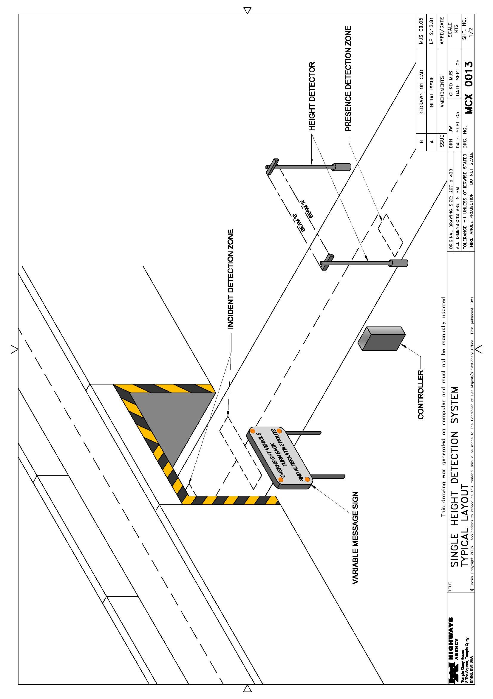
Figure. 1.1
Single Height Detection System (Typical Layout equivalent height detection to specification requirements can be used)

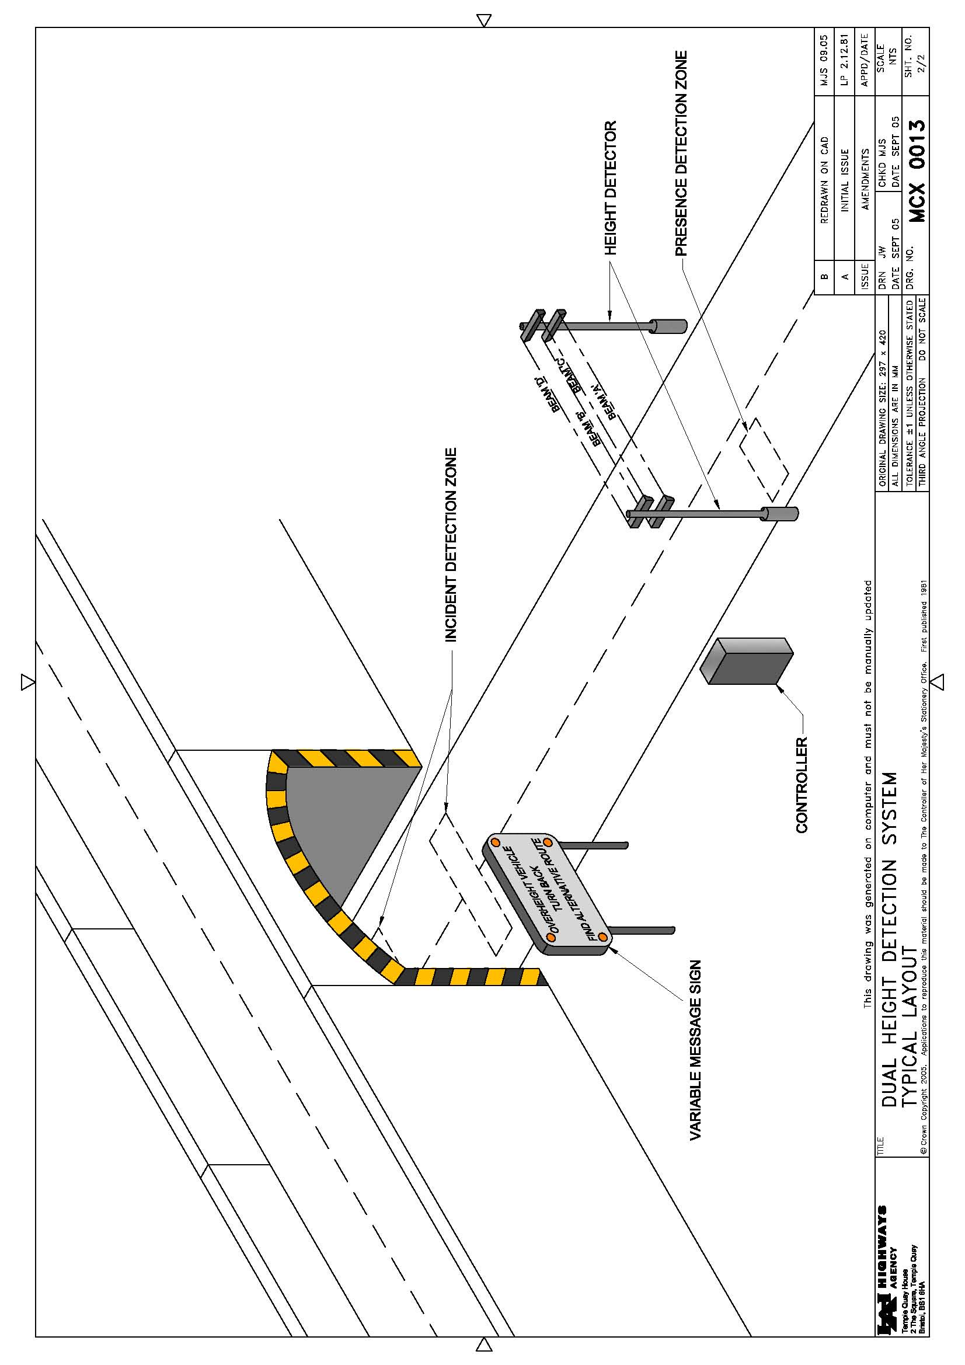
Figure 1.2
Dual Height Detector System (Typical Layout equivalent height detection to specification requirements can be used)

3.References

Where undated references are listed, the latest issue of the publication applies.
The British Standards Institution, London, publishes British Standards.
TOPAS 2130 | Environmental Tests for Road Traffic Control Equipment
TOPAS 2505 | Above Ground Vehicle Detector Systems for Permanent Traffic Signals
TOPAS 2512 | Inductive Loop Vehicle detection Equipment
TOPAS 0600 | Self-Certification Procedures for Statutory Approval of Traffic Signal Control Equipment
TOPAS 2546 | Passively Safe Products
BS EN 50556 | Road Traffic Signal Systems
BS EN 12368 | Traffic Control Equipment – Signal Heads
BS EN 12767 | Passive safety of support structures for road equipment - Requirements and test methods
BS EN 12966 | Road vertical sign - Variable message traffic signs
BS EN 50293 | Electromagnetic Compatibility Road Traffic Signal Systems Product Standard
BS EN 60825 | Safety of laser products Part 1: Equipment classification, requirements and user's guide
BS EN 60068 | Environmental testing
BS EN 60529 | Degrees of protection provided by enclosures (IP Code)
TSRGD | Traffic Signs Regulations and General Directions
Directive 89/336/EEC | EMC Regulations 1992, (Statutory Instrument 1992 No 2372)

The drawings in figures 1.1 and 1.2 are reproduced from Highways Agency drawings MCX0013 sheets 1 and 2.

Appendix A Sign Legends for Over Height Vehicle Detection Systems

A1. These mandated legends are reproduced from TSRGD which takes precedence.
A2. The signs shall be capable of displaying authorised legends that contain words to convey the following information to vehicle drivers. The legends may also contain symbols.
Legend type A – A blank face
Legend type B – Instruction for a driver of an over-height vehicle to take avoiding action.
Legend type C – Instruction for the driver to use the middle of the road when clear.
Legend type D – Warn drivers that a high vehicle may be approaching in the middle of the road.
Legend type E (Optional) – Warn drivers to check height of vehicles – for use in the event of equipment failure.
A3. Legend type B may be used in conjunction with diagram 818.5 in TSRGD 2016 or as provided by a DfT site specific authorisation obtained by the Local Authority
Notes on use of TSRGD diagram 818.5
- The legend “south of Maplebeck” may be varied as appropriate or omitted
- The numerals giving a height may be varied
- A distance to the low bridge may be shown in accordance with Part 3 of Schedule 18
- An arrow pointing horizontally to the left or to the right may be added
- “ahead” may be added after any distance where an arrow has not been added
- The legend below the “height limit” symbol, indicating an alternative route, may be omitted or varied and may include the legends shown in column 3 of the sign table in Part 3 at item 8

Appendix B Remote Monitoring Over Height Vehicle Detection Systems

Where a Outstation Monitoring Unit is connected to the Overheight Vehicle Detection system It must provide digital outputs compatible with TR2523 for the following status and fault signals.
Mandatory
- Controller Working
- Error OHVD Height Detector 1
- Error OHVD Height Detector 2 (Dual height)
- Error Non Critical Pixel Failure VMS
- Error Critical Pixel Failure VMS
- Signal OHVD
- VMS Manual Override
Optional
- OVD Controller Door Open
- Flasher Failure
- Error VPD Detector
- Power OK
- VPD Active
- Signal Message (Sign Activated)

APPENDIX Z technical file content

This appendix defines the necessary content for a Technical File Pack (a collection of relevant documents) which must be reviewed by an appropriate Notified Body as part of the TOPAS Registration process (See TOPAS 0600).

Only the ‘ticked’ items are required to be present in a Technical File Pack used to support TOPAS Registration against TOPAS 2515D.

Ref | Item | Description | Required
1 | Technical File overview document. | A summary document outlining the product, specifying which TOPAS and other relevant specification(s) the product has been designed to comply with, together with a detailed table of contents for the Technical File Pack.  Where copies of external certificates or documents are referred to these may be included within the Technical File overview document or supplied separately as part of the Technical File Pack.
2 | QA accreditation certificate(s). | A copy of the Quality Management Registration Certificates for the organisation applying for TOPAS Product Registration.
3 | Details of all CE markings that apply to the product. | A list of all directives complied with and how achieved. Typically this would be references to explicit CE Technical Files and certificate’s, copies of which would be included in the Technical File Pack.
4 | A functional design description of the product. | A reference to the overall System Design Documentation for the product (by document part number and issue).
5 | Product part numbers | A list of top level assembly part numbers and their issue states including all firmware / software part numbers and issues.
6 | Statement of compliance | A clause by clause statement of compliance against TOPAS 2515B confirming compliance and/or listing caveats or deviations.
7 | Test procedures and results | A reference to all test schedules and test result documents (by document part number and issue).
8 | EMC test results | A reference to EMC test performance requirements. Copies of the results of EMC testing undertaken by an appropriately qualified independent approved test house must be included in the Technical File Pack.
9 | Optical test results | A reference to Optical tests performance requirements. Copies of the results of Optical testing undertaken by an appropriately qualified independent approved test house must be included in the Technical File Pack. | N/A
10 | Environmental test results | A reference to Environmental tests performance requirements. Copies of the results of the Environmental testing undertaken by an appropriately qualified independent approved test house must be included in the Technical File Pack.
11 | Radio Agency test results | A reference to Radio Agency tests performance requirements. Copies of the results of Radio Agency testing undertaken by an appropriately qualified independent approved test house must be included in the Technical File Pack. | N/A
12 | Primary Safety Test results | For Traffic Control equipment specifically a reference to the Primary Safety Test schedule and test results by part number and issue. A copy of the test results should be included as part of the Technical File Pack.
13 | Failure Mode Analysis | A reference to the product failure mode analysis and results by document part number and issue. | N/A

